You are cordially invited to exhibit at
“Altered States Open Air Sculpture Exhibition”
At Shaw House, Church Road, Newbury, RG14 2DR
From Saturday 1 August – Sunday 27 September 2026

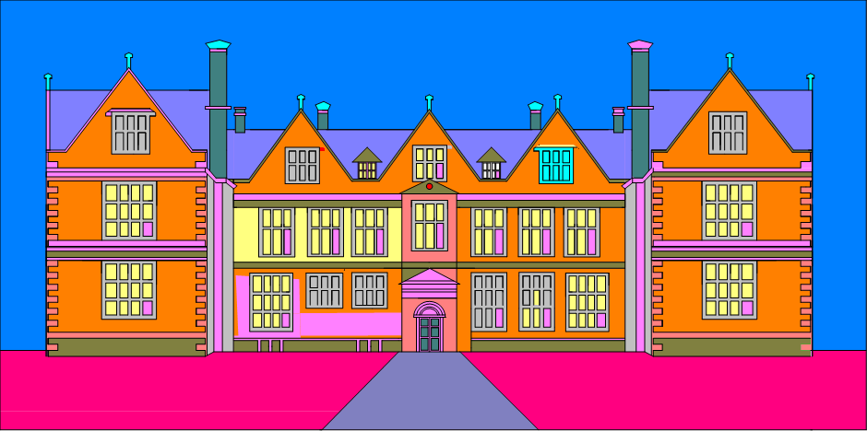

Dates: Installation on Monday 27 July – Friday 31 July, open from 9.30-5pm.

Show open Saturday 1 August - Sunday 27 September from 11.00 - 4.00.

The House, grounds, shop and café will be open every day during the school holidays.

Title: “Altered States Open Air Sculpture Exhibition”.
Curator: Jim Crockatt

Number of sculptures: 90 sculptures to be located at Shaw House.
The exhibition: It is envisaged that the exhibitions will consist of large sculptures, (no less than 600mm in height) supplied by the artist. The artists can either select from work they already have or can design and make a sculpture to reflect the site if they so please.

Organizing the shows: The participating artists are to be responsible for transporting and erecting their work for the show and taking the exhibition down and removal of their work. It is important that the plinths are secure enough to protect the work from the visitors and to protect the visitors from the work. The securing of the plinths should not exceed 300mm below ground at Shaw House as the land is an archaeological site and therefore all due care and attention should be considered when securing your work. There will be staff on hand to help in securing the work.

There is easy access by car and trailer right up to the locations.
We will need to carry out a risk assessment for the installation of the sculptures upon arrival.

Shaw House is a Grade 1-listed building and it is not permitted to attach any work to the brick walls.

The exhibitor should be on site for installation and for removing the work even if a piece has been sold it and it needs to go to the purchaser’s location. The exhibitor would be required to sign it off on arrival and ditto on removal. Please bring your own tools. The sculptures will be numbered the Friday before the show.
The curator will be happy to show an exhibitor the site before the show by emailing him at jimcrockatt@gmail.com.

Stewarding: The curator will be at Shaw House at the weekends. There is a receptionist at Shaw House 7 days a week. You are encouraged to come and do your stint if you have time as the more stewards on site the more contact time with potential buyers. This is not a condition but merely an encouragement.

Website: is www.alteredstatessculptures.co.uk. The website constitutes a Home page linked to Shaw House with an Introduction to the exhibition on the “About” page, an “Artist” page, a “Plan your visit” page, a “Submit”, a “Buying sculpture” page, a Virtual page showing the sculptures that are to be exhibited, and a Price List page. Each sculptor has a page to submit 300 words of self- promotion and 4 x jpeg images.

Publicity: Shaw House will advertise in their “Spring and Summer What’s On” Brochure as well as Facebook, and Instagram. They will also have a listing on their website www.westberkshireheritage.org/whats-on. The exhibition will be publicized on their monthly events newsletter which has over 5000 subscribers and on the main Council newsletter which goes out to the residents of West Berkshire.
Shaw House is committed to Social Media
Below are the statistics of their social media output and responses for 2025
exhibition:

Facebook advert
Total people reached x9,850
Event responses x167
Website clicks x192

Facebook posts
Number of posts x12
Total people reached x22,344

Instagram
Number of posts x12
Total people reached x1859

Total social media reach x34053

Dreweatts Auction House has kindly offered to publicize the exhibition with an article in the monthly newsletters out for June, July and September, which has a mailing list of 3600 clients.

The curator will be updating Newbury Weekly News with copy leading up to the event which will also be reviewed for the following week after the opening.

500 X A5 single sided classic silk posters and 250 X A4 single sided classic silk posters will be purchased for distribution in Newbury and surrounding areas.

10 X 183cm X 76cm vinyl banners will be purchased for distribution at focal points in Newbury.

Publicity will be sent to different relevant organisations, including schools and regional subsidiaries, publications and landowners throughout the Home Counties.

We will launch a campaign to promote the exhibition on our social media platforms in the lead up and during the event.

Numerous Facebook and Instagram images will be sent out during the show by mobile photographers.

It is encouraged that sculptors will use social media to help publicise the event and tag our main sites in your posts so that we can reshare;
Facebook @alteredstatessculptures @ShawHouseEvents
Instagram @alteredstatesex @shawhouse1581
The curator will be interviewed by Kennett Radio before and during the show.
The curator also has his own show called Art For Art’s Sake on Kennet Radio facilitating a generous amount of promotion of the show.

Entrance Fee: There will be an entrance fee of £35 per sculptor which cumulatively is intended to cover all expenses of the exhibition. If you are happy to show your works please notify the curator and then transfer £35 to Barclays Bank sort code 20-59-14 and account no: 60553948. Please prefix your name with AS. And my account name is MR JJN CROCKATT.
Footfall: Last year there were 13,298 visitors to the exhibition. The population of Newbury is 153,822.

Commission: There is a 15% commission.

Selling: The buyer will pay the money into the sculptor’s account and the sculptor will in turn, pay 15% into the curator’s account as shown above. The reception staff can take expressions of interest and will contact the curator directly to follow up the sale. The curator can expect the commission up to 3 months after the end of the show if interest was shown by the purchaser at the show.
Number of pieces: Artists are normally to be limited to exhibiting 3 pieces.
Business Cards: Artist’s business cards can be made available in the foyer.

Insurance: Each artist must have and produce a certificate of public liability with a minimum indemnity of not less than £5 million to cover negligence. Artist newsletter offers some good deals. As the works will not be insured by the venues, artists are required to fully insure their own works prior to their arrival on site. Please provide proof of insurance with the submission form.

Security: is such that all drives are closed during the hours from 5pm - 8am, depending on other events and activities in the house, therefore there would be no way a car or van could get onto the premises.

During the day there are many visitors which would make it hard for a theft to go undetected.
There is a steward/ receptionist on site during the week from 11- 4pm. The exhibition site will be stewarded on the weekends.
To date we have never had a theft or damage to the sculptures.

Entrance to the Exhibitions: The exhibition is free to visitors.

Submissions: Submissions are to be submitted using the template attached including photographs to enable appropriate setting out of the exhibition. The photographs are to be of a good quality (a minimum size of 300 dpi) as they might be used for publicity material. It is also required that the artist states how or if the work is to be secured. The artist also needs to state the number of editions available. The insurance certificate should also be attached as well as the submission fee of £35.

Visitor Feedback:

‘Always worth a visit. I usually go at least twice.’
‘Really looking forward to visiting again this year. And for tea and cake!’
‘Lovely morning/ afternoon activity’
‘Look forward to it every year!’
‘Love this! Visit every year.’
‘Lovely exhibition.’
‘We loved our visit today - thank you for making this an annual tradition for our Summer holidays.’
‘We went yesterday. It's well worth a visit.’
‘Coming for our annual visit tomorrow with friends. Lovely, as it always is.’
‘Love this!’

For further information about the show: contact Jim Crockatt 07868754283 and on email: jimcrockatt@gmail.com.
Go to Altered States Sculpture Exhibition -YouTube to see a panoramic view of the show.

I am sure it will be a most excellent adventure!
Jim Crockatt- Curator

